**Habitat quality influences *Aedes*, *Anopheles* and *Culex* larval abundance and co-occupancy in Edo state, Nigeria**

# Abstract

Certain mosquito species within the genera *Aedes*, *Anopheles*, and *Culex* are known to transmit diseases such as malaria, yellow fever, Zika, dengue, and lymphatic filariasis. They occupy extensive grounds and a broad range of breeding environments in tropical and subtropical regions of the world, which makes them threatening to public health. Habitat qualities, as defined by a range of physicochemical properties, habitat types and species co-occupancy, influence female mosquito site preference for oviposition and larval development. Understanding these extrinsic factors that influence mosquito breeding success is important for their control. We surveyed 32 breeding sites in Edo State, Nigeria, that were positive for at least one living mosquito larva, assessing 17 physicochemical properties and categorizing habitat types (as containers, gutters, puddles, used tyres, and tyre tracks). We evaluated the predictive ability of these habitat qualities on mosquito larval abundance. *Anopheles* larvae were more abundant in tyre tracks, puddles, and gutters, which were characterized by high variability in physicochemical properties, compared to containers and used tyres. *Aedes* larvae were most abundant in puddles and used tyres, showing high dissimilarity in habitat preference compared to *Anopheles*. The abundance of *Aedes* mosquitoes was positively associated with chloride but negatively with suspended solids, colour, Total Dissolved Solids (TDS), and *Anopheles* larval population. *Culex* larvae were predominantly found in used tyres and were negatively associated with pH, turbidity, and TDS, but positively associated with nitrates. Containers and used tyres had more similar and homogeneous physicochemical properties, favouring *Culex* and *Aedes* breeding. Furthermore, *Aedes* showed greater dissimilarity in habitat type preference compared to *Anopheles*. This study highlights the complexity of the ecological control of mosquitoes in Edo state, Nigeria, due to their environmental adaptability. It provides insights into the ecological dynamics and interactions between mosquito species and abiotic factors in aquatic environments.

**Keywords:** Mosquito larvae, habitat quality, species-occurrence, physicochemical properties, vector control

# 1. Introduction

As one of the most important insect vectors, mosquitoes can spread a variety of pathogens that affect both human and animal health. Many mosquito species that transmit illnesses like malaria, yellow fever, Zika, dengue, chikungunya, West Nile virus, and lymphatic filariasis are found in the genera *Aedes*, *Anopheles*, and *Culex* (Jupp, 2005; Dodson & Rasgon, 2017; Eneanya et al., 2018; Nebbak et al, 2022). Due to their extensive geographic spread and their broad range of breeding environments, they are threatening to public health, especially in tropical and subtropical regions of Africa and Asia (Awolola et al., 2007; Chua et al., 2004; David et al., 2021; Muturi et al., 2007).

Mosquitoes propagate by female adults ovipositing in suitable breeding sites. Her choice of egg-laying is reprimanded by environmental and physiological factors (Chua et al., 2004; Muturi et al., 2007). Gravid females use visual cues and olfactory chemosensors to detect and evaluate potential aquatic habitat quality (Turnipseed et al., 2018). They are highly receptive to the volatile organic compounds released from stagnant water sources like containers, tyres, puddles, gutters, and natural pools (Chua et al., 2004; Medeiros-Sousa et al., 2020). These chemosignals provide information on the presence of microbial communities and nutrients that will support larval growth (Turnipseed et al., 2018). Female mosquitoes also use non-chemical cues when choosing egg deposition sites. They prefer temporary, stagnant water bodies with no predators and high organic content that offer nutrition for filter-feeding larvae (Benelli, 2015).

The qualities of water in breeding sites play a crucial role in both the laying of eggs and the growth of mosquitoes. This habitat quality may be shaped by many factors including physicochemical properties, competing species and habitat structure (Benelli, 2015; Chua et al., 2004; David et al., 2021; Medeiros-Sousa et al., 2020; Mwangangi et al., 2009). Physicochemical factors such as temperature, turbidity, acidity, and the concentrations of various substances, including ammonia, nitrite, nitrate, sulfate, phosphate, chloride, calcium, and hardness of the water are critical for egg hatching and larval development success (Awolola et al., 2007; Medeiros-Sousa et al., 2020; Nikookar et al., 2017). Furthermore, habitat types such as tyres, containers, puddles, tyre tracks and gutters may have differential potentiality for mosquito oviposition and larval development (Awolola et al., 2007; Medeiros-Sousa et al., 2020; Mwangangi et al., 2009; Nikookar et al., 2017). Understanding how different habitat qualities govern the abundance and richness of mosquito vector species is crucial for disease prevention and mosquito control efforts.

Nigeria experiences high rates of mosquito-borne diseases like malaria, lymphatic filariasis, and dengue fever (Eneanya et al., 2018; Awosolu et al., 2021). Gaining insights into mosquito breeding behaviour and ecology is crucial for vector-borne disease eradication efforts (Chua et al., 2004). Recent control strategies have focused on manipulating larval growing conditions (Zoh et al., 2022). However, most studies have concentrated on single populations, leaving a gap in understanding the multivariate effects of physicochemical properties on multiple mosquito populations (Silberbush & Blaustein, 2008; Mwangangi et al., 2009). This gap highlights the need for further study on the physicochemical characteristics of mosquito larval habitats.

We conducted a field study to estimate the multivariate effects of physicochemical properties of water and species co-occurrence on *Aedes*, *Anopheles*, and *Culex* larval abundance. We also investigated the differences in abundance across various habitat types in three ecological zones, aiming to identify the most critical physicochemical properties affecting larval occurrence.

# 2. Materials and methods

**Insert other sections of the materials and methods**

## Data analysis

Statistical analyses were conducted using R version 4.1.3. Habitat types were categorized into five categories: container, gutter, puddles, tyres, and tyre tracks. Only sites that were positive for at least one mosquito sample were included in the analysis.

Principal component analysis (PCA) of physicochemical parameters was conducted using the FactoMineR package. Graphical representations were created using ggplot from the ggplot2 package, while PCA biplots were generated using fviz_ca_biplot from the FactoExtra package.

A generalized linear mixed-effects model (GLMM) was developed using a stepwise regression approach with forward selection, employing a Poisson distribution and a log link function. Only most contributing variables (i.e., those that contribute more than the average contribution) from the PCA were included as predictors in the GLMM. Before model construction, predictor variables underwent z-score transformation, resulting in a significant enhancement of the model's performance. Predictor variables with statistical significance (p < 0.05) were included as fixed effects, while ecozones and habitat types were incorporated as random effects due to their impact on observations. Model selection was guided by second-order Akaike’s information criterion (AIC) scores and Bayesian Information Criterion (BIC), with a series of trial models compared using the anova function. GLMMs were implemented using the lme4 package and the glmer function.

Separate negative binomial models were fitted to assess the impact of habitat type on *Aedes*, *Anopheles*, and *Culex* mosquito abundance. Negative binomial models (NBM) were chosen over Poisson models due to observed over-dispersion in the data. The model was built with a log (x + 1) transformation applied to the mosquito abundance variables prior to computing the NBM. To assess differences among each habitat, Tukey tests for multiple comparisons were conducted using the "glht()" function from the "multcomp" package (Hothorn et al., 2008), given the existence of five distinct habitat levels.

Correspondence analysis (CA) plots were employed to ordinate mosquito species associated with habitat types. Before this analysis, a significant dependence (p < 0.05) in the abundance of the mosquito genus across habitat types was confirmed using the chisq.test function. Following this, a correspondence analysis biplot was generated using CA for analysis and fviz_ca_biplot for visualization.

# 3. RESULT

In total, 642 individual mosquito larvae were collected across all sites. This includes 91 *Anopheles*, 200 *Culex* and 351 *Aedes* species. Overall, most mosquitoes were collected from used tyres (320), puddles (210) and containers (43) (see Table 1). Also, tyre track had no *Culex* or *Aedes* mosquito, while containers had no *Anopheles* mosquitoes. The correspondence analysis (CA) biplot showed that *Aedes* was most associated with containers and puddles, *Culex* with used tyres, and *Anopheles* with Tyre tracks (Figure 5). This supported evidence shown in the descriptive statistics. For example, *Culex* had a high prevalence in used tyres (12.23±4.27), and *Anopheles* was mostly found in tyre tracks (7.0±6.0).

Table 1: Mosquito larvae collected at the sampling locations and their abundance.

|  |  |  |  |  |  |
| --- | --- | --- | --- | --- | --- |
| Habitat (n) | *Anopheles* (%) | *Culex* (%) | *Aedes* (%) | Mean ± SD | Total |
| Containers (6) | 0 | 4 (2.00) | 39 (11.11) | 7.17±11.29 | 43 |
| Gutters (3) | 21 (23.08) | 12 (6.00) | 2 (0.57) | 11.67±17.62 | 35 |
| Puddles (5) | 25 (27.47) | 25 (12.50) | 160 (45.58) | 42.00±70.03 | 210 |
| Tyre track (5) | 34 (37.36) | 0 | 0 | 6.80±6.49 | 34 |
| Used tyres (13) | 11 (12.09) | 159 (79.50) | 150 (42.74) | 24.61±20.78 | 320 |

*n= number of samples; SD= Standard Deviation*

*\* % relative to the total number of mosquitoes found in the respective genus.*

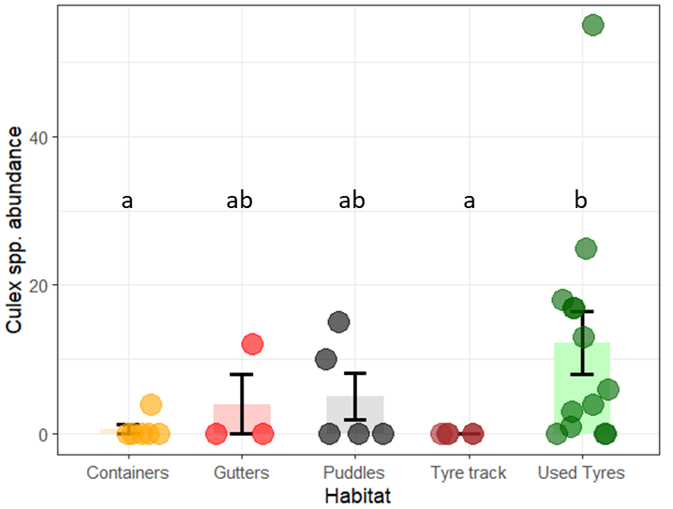

***Figure******1:*** *Abundance of Culex spp. larva at the artificial habitat. Error bar represent standard error of mean. Statistical Significant difference are indicated by differences in letters.*

There was no *Culex* larva in tyre tracks. However, used tyres, puddles and gutters had mean populations of 12.23±4.27, 5.0±3.16 and 4.0±4.0 respectively, and were not statistically different from each other. Furthermore, an average of 0.67±0.67 *Culex* larva was found in containers, but was not statistically different from the *Culex* status in used tyres (0).

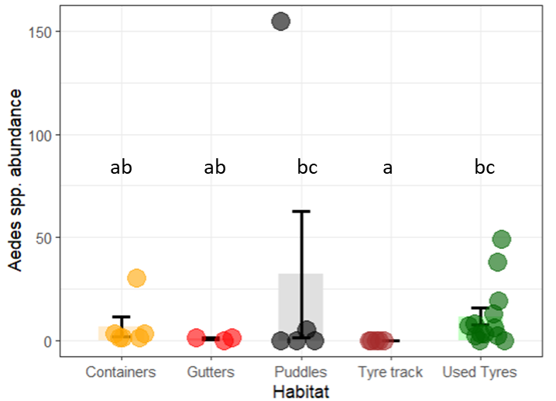

**Figure 2**: *Abundance of Aedes spp. sampled at the artificial habitat. Error bars indicate standard error of mean. Dissimilar letters indicate statistically significant difference*

Similar to the occurrence among the sampled *Culex* larvae, tyre tracks had no occurrence of *Aedes* larvae. Here, puddles had the highest count (32±30.77) of *Aedes* larvae, though not statistically differing from that in used tyres (11.54±4.25). Furthermore, *Aedes* abundance in containers and puddles habitats did not differ significantly from tyre tracks (which had no larvae).

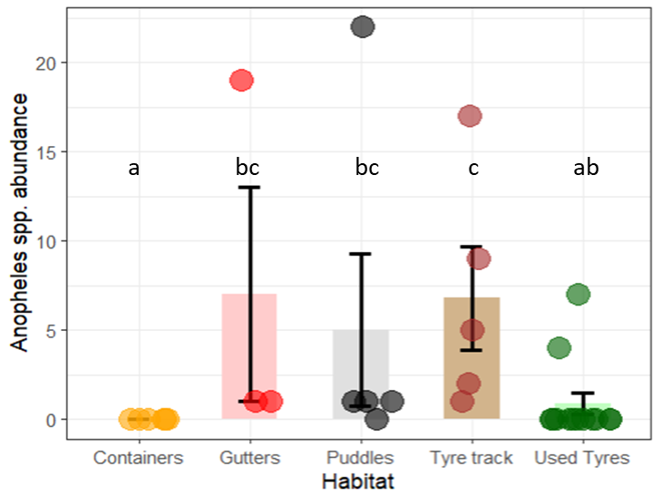

Figure 3: *Abundance of Anopheles spp. larva sampled at the artificial habitats. Error bars indicate standard error of mean*. *Dissimilar letters indicate statistically significant difference*

For *Anopheles*, Gutters, tyre tracks, and puddles exhibited mean larval counts of 7.0±6.0, 6.8±2.91, and 5.0±4.25, respectively, with no significant statistical variance observed among them (P>0.05). Unlike the case for *Aedes* and *Culex* samples, the containers had no *Anopheles* larva.

Descriptive statistics of the physicochemical properties as they differ by habitat type are summarized in Table 2. The 17 physicochemical parameters assessed is presented in a two-dimension PCA plot (Figure 6). The first two axes of the PCA explained 55.5% of total variation in the data. Specifically, the first axis accounted for 41.2% of data variance, with total solid, suspended solid, colour, magnesium, sulphate, hardness, chloride, turbidity and nitrate as the variables that most contributed to explaining the dataset variation. All physicochemical parameters were positively correlated with the first PCA dimension, except for DO (Figure 6). On the other hand, TDS, conductivity, alkalinity, pH, phosphate and turbidity were the main contributing variables explaining the second component axis which account for 14.3% of the variance (Figure 7).

PCA of the habitats and ecozones is represented in the biplot Figure 4. Puddles and tyre tracks had the most heterogeneous clusters. Containers and used tyres were the most homogenous, with some overlap in their clustering. Furthermore, the PCA ordination showed little disparity in the homogeneity physicochemical characteristics of each ecozones. From the ordination plot, the lowland rainforest appeared more homogenous sites, relative to derived savanna and freshwater swamps sites which were heterogeneous.

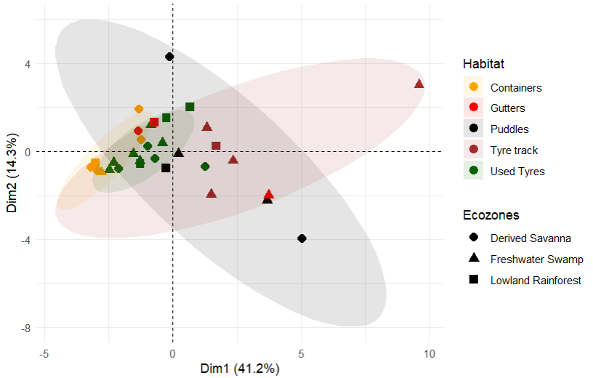

**Figure 4**: P*CA of habitat and their ecozones showing similarity of physicochemical properties in the sites (N= 32).*

*\*Ellipse was set to a 95% confidence interval (CI).*

*\* CI could not be calculated for “Gutters” due to too few data points.*

Table 2: Physicochemical properties of mosquito larva habitats, represented as mean ± standard deviation (I am not too sure of the exact unit of measurement. It should be added for each physicochemical paremeter)

|  |  |  |  |  |  |
| --- | --- | --- | --- | --- | --- |
| Habitat | Container | Gutters | Puddles | Tyre tracks | Used tyres |
| pH | 6.15±0.35 | 7.03±1.21 | 6.94±0.67 | 7.3±1.01 | 6.6±0.88 |
| Colour | 81.16±36.82 | 1878±2877.07 | 3139.6±2781.72 | 4153.4±31 | 608.15±797.83 |
| Turbidity | 12.333±7.94 | 436.33±661.42 | 817.4±842.95 | 855.8±484.35 | 77.92±89.82 |
| TDS | 57.42±67.32 | 81.27±46.31 | 108.12±104.37 | 106±64.04 | 70.94±30.94 |
| Suspended Solid | 8.33±5.98 | 250.67±378.77 | 374±324.79 | 776±687.10 | 129.92±278.72 |
| Total Solid | 65.75±67.47 | 331.93±370.20 | 482.12±287.72 | 882±730.19 | 200.86±273.88 |
| Conductivity | 108.33±127.03 | 153.33±87.37 | 204±196.93 | 200±120.83 | 133.85±58.39 |
| Chloride | 14.12±6.31 | 32.94±4.07 | 50.832±40.06 | 39.536±22.66 | 22.81±16.34 |
| Alkalinity | 29.33±21.75 | 86±72.58 | 57.6±15.71 | 87.2±66.19 | 53.85±35.11 |
| Hardness as CaCO3 | 25.67±29.59 | 53.33±41.05 | 83.6±66.31 | 116.4±68.31 | 54.15±36.28 |
| Phosphate | 0.49±0.40 | 3.67±2.49 | 36.082±74.12 | 5.046±3.51 | 1.13±0.99 |
| Sulphate | 17.5±18.98 | 88.67±101.93 | 35±26.63 | 119.8±128.26 | 29.46±14.40 |
| Nitrate | 5.94±7.43 | 28.73±37.18 | 28.538±25.68 | 27.14±17.71 | 10.75±11.95 |
| DO | 7.38±1.58 | 4.8±4.42 | 2.62±1.64 | 3.82±2.49 | 4.08±1.82 |
| BOD | 2.56±1.42 | 16.03±20.67 | 10.282±6.69 | 12.54±17.42 | 9.09±14.66 |
| Calcium | 7.61±11.61 | 18.95±15.45 | 26.934±21.08 | 28.70±19.31 | 16.28±13.40 |
| Magnesium | 1.38±1.08 | 1.62±1.13 | 3.988±3.64 | 10.79±9.70 | 2.62±1.65 |

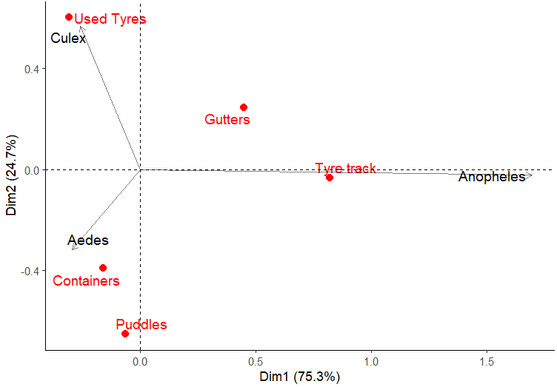

**Figure 5:** *Correspondence analysis (CA) biplot representing the relationship between mosquito larvae and the habitat type.*

.

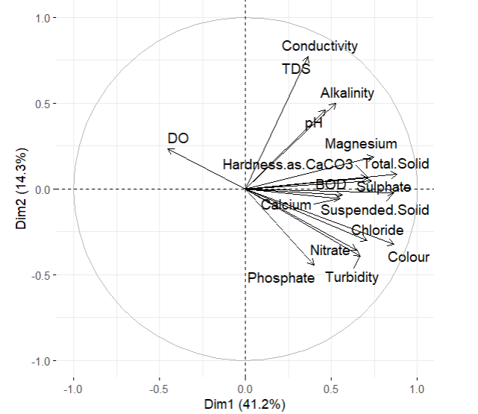

**Figure 6:** *Principal component analysis (PCA) biplot showing physicochemical parameters of sampling sites in a two-dimensional space.*

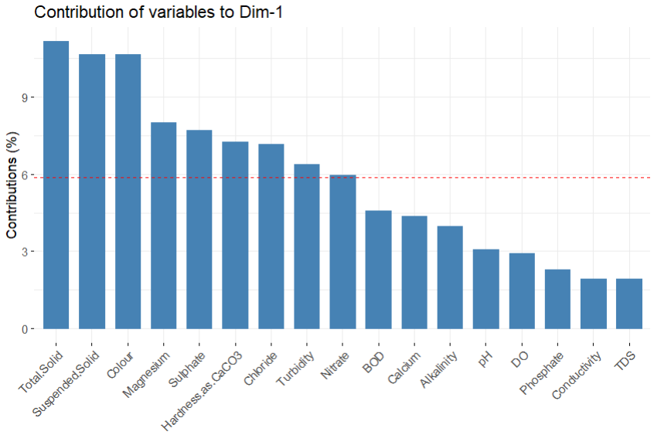

Figure 7: *Contribution of physicochemical characteristics surveyed to the first principal component dimension.*

*\*The red dashed line in the visualization represents the average contribution of the variables to the first principal component axis. Variables with bars above the dashed line contribute more than average to the axis (and vice-versa).*

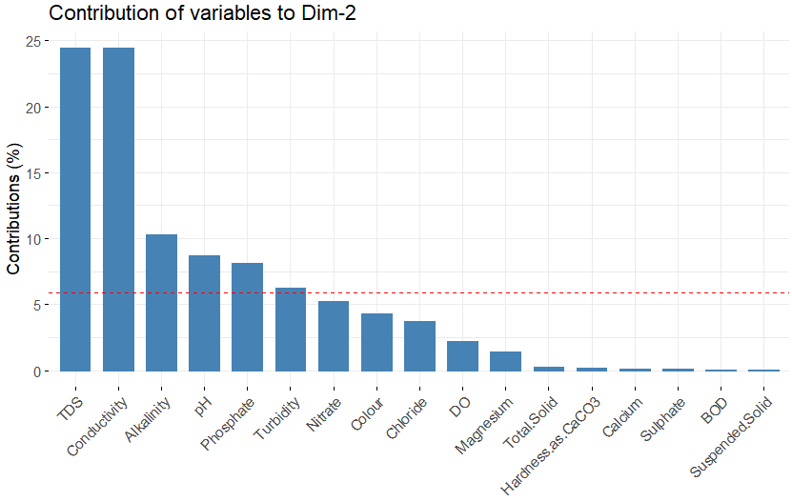

Figure 8: Contribution of physicochemical characteristics surveyed to the second principal component dimension.

* *The red dashed line in the visualization represents the average contribution of the variables to the second principal component axis. Variables with bars beyond the dashed line contribute above average to the axis (and vice-versa).*

Table 3: Results of the generalized linear mixed model (GLMM) of the number of immature *Anopheles* in larval habitats.

|  |  |  |  |  |  |  |
| --- | --- | --- | --- | --- | --- | --- |
| **Dependent variable** | **Effect** | **Term** | **Estimate** | **SE** | **Z-Value** | **p-value** |
| *Anopheles* Count | Fixed | Intercept | 0.1942 | 1.2795 | 0.152 | >0.05 |
|  |  | Turbidity | -0.6205 | 0.1857 | -3.341 | <0.001 |
|  |  | Magnesium | -0.7247 | 0.1710 | -4.238 | <0.001 |
|  |  | pH | -0.5958 | 0.1520 | -3.921 | <0.001 |

We used the most contributing PCA variables according to the first and second axis (Fig 7 & 8) and *Culex* and *Aedes* abundance to predict *Anopheles* abundance. The GLMM showed that Turbidity, Magnesium, and pH negatively (P < 0.05) influenced the *Anopheles* abundance (Table 3).

Table 4: Results of the generalized linear mixed model (GLMM) of the number of immature *Aedes* in larval habitats.

|  |  |  |  |  |  |  |
| --- | --- | --- | --- | --- | --- | --- |
| **Dependent variable** | **Effect** | **Term** | **Estimate** | **SE** | **Z-Value** | **p-value** |
| *Aedes* Count | Fixed | Intercept | -0.5580 | 1.4129 | -0.395 | P >0.05 |
|  |  | *Anopheles* Count | -1.2163 | 0.2735 | -4.448 | P<0.001 |
|  |  | Suspended Solid | -0.7419 | 0.1582 | -4.688 | P<0.001 |
|  |  | TDS | -1.6200 | 0.1291 | -12.544 | P<0.001 |
|  |  | Chloride | 0.5479 | 0.1353 | 4.049 | P<0.001 |
|  |  | Colour | -2.7449 | 0.3086 | -8.894 | P<0.001 |

Most contributing physicochemical properties in according to the PCA (Figure 7 & 8) in addition to *Anopheles* and *Culex* abundance were used as GLMM fixed effect predictors for *Aedes* count. Colour, TDS, suspended solid and *Anopheles* population were significant negative predictors of *Aedes* population, while Chloride was the only significant positive predictor (Table 4).

Table 5: Results of the generalized linear mixed model (GLMM) of the number of immature Culicidae in larval habitats.

|  |  |  |  |  |  |  |
| --- | --- | --- | --- | --- | --- | --- |
| **Dependent variable** | **Effect** | **Term** | **Estimate** | **SE** | **Z-Value** | **p-value** |
| *Culex* Count | Fixed | Intercept | -1.1405 | 1.2833 | -0.889 | P>0.05 |
|  |  | Turbidity | -4.6823 | 0.6625 | -7.068 | P<0.001 |
|  |  | pH | -0.5527 | 0.1095 | -5.046 | P<0.001 |
|  |  | Nitrate | 2.2995 | 0.3123 | 7.364 | P<0.001 |
|  |  | TDS | -1.4212 | 0.2795 | -5.083 | P<0.001 |

*Culex* density was most affected by turbidity, pH, nitrate, and TDS. GLMM showed that turbidity, pH, and TDS had negative relationships with *Culex* density. On the other hand, the model shows that *Culex* were associated with increased nitrate (Table 5)

# 4. DISCUSSION

In this study, we investigated the relationship between the physicochemical properties of mosquito larval habitats and mosquito abundance. Our study delved into the co-occurrence patterns at these sites, driven by the hypothesis that certain habitat types might be more conducive to breeding specific mosquito genera over others. This differentiation could stem from the distinct physiological and nutritional demands of the mosquitoes. By surveying 32 sites, we recorded the abundance of *Aedes, Anopheles* and *Culex* mosquito larvae along with 17 water physicochemical parameters. Our analysis revealed variables that significantly influenced larval abundance and highlighted notable disparities in habitat preferences among mosquito genera. Furthermore, we examined the homogeneity of physicochemical properties across breeding sites, hypothesizing its impact on habitat selection. In the following sections, we will discuss these findings in detail, offering insights into the factors shaping mosquito habitat preferences and their implications for vector management.

## 4.1 *Culex* Abundance

We found that *Culex* larvae were most associated with used tyres, which was not surprising. A study in some villages in Rivers State, Nigeria by Okiwelu & Noutcha (2012) showed that 80% of sampled *Cx. quinquefasciatus* were in container-type breeding sites, which included tyres, plastic containers and ‘calabashes’. Obi et al. (2020) also reported a high occurrence of mosquito larvae in used tyres compared to other breeding sites like rock poles and electric poles. Furthermore, among the 17 physicochemical properties we assessed, *Culex* was negatively associated with pH, turbidity and TDS, and was positively associated with nitrates.

We observed that lower turbidity of water in containers supported *Culex* larvae abundance. Contrastingly, Muturi (2007) reported *Cx. quinquefasciatus* was positively associated with turbid water, but also reported that *Cx*. *annulioris* larvae have been more associated with clear water, indicating some level of intra-genus difference in their preference. We reported low turbidity in containers, which may result from low organic matter in the water (Muturi, 2007). In our study, *Culex* was most associated with used tyres which were less turbid compared to puddles, gutters, and tyre tracks. The presence of *Culex* larvae in less turbid waters may be due to several factors: Firstly, lower turbidity often indicates cleaner water, which could reduce competition for resources and lower predation rates. Secondly, clearer water may have better oxygenation, supporting *Culex* larvae development. Lastly, habitats with lower turbidity, like used tyres, may provide more stable microenvironments with fewer fluctuations in water quality compared to more turbid waters found in puddles, gutters, and tyre tracks.

Our study indicates that used tyres, which had a pH of 6.6±0.88, had the highest mean abundance of *Culex* larvae compared to other habitats. We were not surprised that our model predicted a negative association with pH, as other habitat types had relatively higher pH levels, except for containers. Soltan-Alinejad et al. (2023) reported 8.3 as the optimum pH level for *Cx. quinquefasciatus* and *Cx. laticinctus*. Again, used tyres may offer stable and protected microhabitats with less pH fluctuation compared to other habitat types. The rubber material of tyres has little influence on water chemistry which supports stable pH for *Culex* larval development.

We found that *Culex* abundance was positively associated with nitrate levels in water. It is known that increased nitrogen level encourages microbial growth, which is likely favourable for mosquito larval growth, since they serve as diet. Research conducted by Kenawy et al. (2013) and Ibrahim et al. (2011) demonstrated a direct relationship between nitrate levels and the density of *Culex* larvae (Darriet and Corbel, 2008).

In our study, the PCA biplot showed a very strong correlation between TDS and conductivity. These parameters had negative relationship with *Culex* abundance. Supportive of our result is the study by Emidi et al. (2017) which reported a negative (though not statistically significant) association of conductivity with *Culex* larvae abundance. In contrast, Nikookar et al. (2017) study in Iran showed that *Cx. pipiens* showed a significant positive correlation with conductivity and chloride, which are indications of dissolved solids.

## 4.2 *Aedes* Abundance

*Aedes* abounded more in puddles and used tyres. They were positively associated with chloride but negatively with suspended solid, colour, TDS and population density of *Anopheles* larvae.

For TDS, Gopalakrishnan et al. (2013) had a similar observation to ours in their study on the effect of physicochemical characteristics on the abundance of container-breeding *Aedes* mosquitoes. They found a negative correlation between the abundance of the mosquito larvae and TDS. Our findings contradict that of Mahata et al. (2022), who found a moderately positive correlation between *Aedes* larvae abundance with TDS. Also, the tolerance of *Aedes* mosquito to habitat turbidity may vary by species. According to Mahata et al. (2022), *A. aegypti* prefers clean water found in different domestic containers inside or near human dwellings, whereas *A. albopictus* is more likely to be present in natural containers or outdoor man-made habitats possessing a greater amount of organic debris.

We found that *Aedes* abundance was negatively associated with suspended solids, which is supported by Overgaard et al. (2017)’s study which found a higher number of *Aedes* in containers in urban regions with lower suspended solids compared to rural regions.

For chloride, we observed a positive correlation with *Aedes* larval density. This is similar to Chatterjee et al. (2015)’s findings, where they observed a high abundance of *Aedes* larval in used tyres and coconut shells with relatively higher levels of chloride compared to other habitat types. In addition, they found the highest *Aedes* larval density in locations with the highest chloride level.

We found that *Aedes* abundance did not increase with *Anopheles* abundance. This may be due to differences in the physicochemical properties of the habitat in which they are found. For *Anopheles*, we saw that they were more abundant in tyre tracks, gutters, and puddles, while *Aedes* were more abundant in puddles, used tyres and containers (which had no *Anopheles*). Here, *Anopheles* were negative predictors of *Aedes* abundance.

## 4.3 *Anopheles* Abundance

We observed that *Anopheles* mosquito larvae were more abundant in tyre tracks, puddles and gutters. This was unlike *Culex* and *Aedes* mosquitoes which had most of their larvae in used tyres and containers. Supportive of this result is in Owolabi and Bagbe (2019)’s study in Oyo state, Nigeria, where road puddles were shown to have the highest level of *Anopheles* sp. Also, Mwangangi et al., (2010) found a high abundance of *Anopheles* larvae in puddles and water pools in their rice agro-village survey of *Anopheles* diversity. Observing the physicochemical properties in larvae habitats from our study, *Anopheles* larvae seemed to prefer conditions of lower magnesium, turbidity and pH.

*Anopheles* were mainly associated with breeding sites that had clearer waters in Ojianwuna et al. (2021)’s study, in Delta State, Nigeria. The association of *Anopheles* larvae with clearer water may be due to their low tolerance for pollution. This is so because clear water likely has higher oxygen levels, which was also true from the outcome of our study. Experiments under controlled conditions have shown that *Anopheles* larvae exhibit higher survival rates, faster development, and better overall fitness in clean water compared to polluted or turbid water (Chirebvu & Chimbari, 2015). They are known to have lower polluted water tolerance than *Aedes* and *Culex* mosquitoes. Clean water tends to have a more neutral pH, while polluted water can be acidic or alkaline, or often contains harmful chemicals, heavy metals, and organic pollutants which can be detrimental to larval physiology and development. In this case, the *Anopheles* larva preferred a lower pH level, which supports the results of less turbidity since turbid waters in environments like puddles and gutters tend to have compounds like ammonia that increase pH.

Our observations on the negative relationship between pH and *Anopheles* were in contrast to Emidi et al. (2017) whose study showed *Anopheles* larvae density was associated with increased pH, having recorded pH between 8.0 – 8.8 in their study. pH in our study sites were within acceptable limits for *Anopheles* larvae survival.

Tyre tracks, puddles and gutters have high variability in their physicochemical properties compared to containers and used tyres where *Anopheles* were barely found. This may mean that *Anopheles* are better adapted to more natural habitats that have higher nutrient fluctuation and variation in physicochemical properties, hence, an advantage, compared to *Culex* and *Aedes* mosquitoes that seem more selective in their habitat.

## 4.4 Mosquito co-occupancy and physicochemical properties of habitat types

We observed a strong positive correlation between conductivity and total dissolved solids, which was not surprising. The connection between electrical conductivity (EC) and total dissolved solids (TDS) has been thoroughly examined, consistently showing a strong correlation between them (Thirumalini & Joseph, 2009; Rusydi, 2018). The physicochemical properties of the habitat indeed differed, and this affected the type of mosquito larvae and the choice of oviposition by gravid female mosquitoes. It seemed that containers and used tyres have more closely related homogenous properties, which may account for why *Aedes* and *Culex* larvae were particularly more abundant in them. Puddles were more heterogeneous in physicochemical properties and seemed to have a fair number of each species of *Aedes*, *Culex* and *Anopheles*. Our PCA biplot shows tyre tracks seemed heterogeneous, but afar off from the relatively homogenous physicochemical properties of containers. This may account for why *Anopheles* were more appreciative of tyre tracks, and absent from containers.

Compared to habitat type, there was no clear distinction in the physicochemical properties of the mosquito sampling sites based on ecozones in Edo state, Nigeria. It may be obvious that the three ecozones (lowland rainforest, freshwater swamp and derived savannah) did not affect preference of the mosquitoes, as much as the habitat type.

The high variability in overall physicochemical characteristics has implications for the tolerance and adaptation of mosquito vectors to diverse environments, complicating control strategies. Limited nutrient exchange with the surroundings results in stable physicochemical conditions and uniform properties in stagnant water environments like containers and used tyres. Over time, microbial communities in such confined water bodies may reach equilibrium, fostering consistent populations and metabolic processes that stabilize the water's physicochemical characteristics. In contrast, puddles and gutters experience greater exposure to environmental fluctuations, including rainfall, runoff, and temperature changes. These dynamic inputs and outputs lead to heterogeneous physicochemical properties that vary spatiotemporally. Puddles and gutters receive inputs from diverse sources such as organic matter, pollutants, and debris washed from the surroundings, further contributing to the water's variability in composition and properties. The open nature of puddles and gutters facilitates greater microbial diversity and activity. The variability in the physicochemical properties of the habitat may be the major determinant of mosquito abundance or species co-occupancy (Mwangangi et al., 2010). However, these habitats have different structures that would accommodate variations in physicochemical properties due to nutrient inflow or outflow from rains, run-off, evaporation and other extrinsic occurrences (Owolabi & Bagbe, 2019).

## 4.5 Study limitations and future research

Some of the unexpected results may stem from the limitations of our study, which we acknowledge. For example, we did not monitor the temperature of the breeding sites, a crucial factor influencing mosquito abundance. Also, we identified mosquito larvae only to the genus level, whereas species within each mosquito genus can have varying physiological requirements, though these differences are generally less significant than those between genera. Additionally, the physicochemical properties of habitats can change due to both anthropogenic and natural factors. Thus, the mosquito larval development is influenced not just by the physicochemical conditions recorded at a single point in time, but by the potential fluctuations in these parameters over time.

Future research should explore the dynamic nature of physicochemical properties in aquatic larval habitats. Studies should consider multiple generations of mosquitoes and their habitat quality to uncover complex relationships that may explain mosquito preferences and potential adaptations. On a habitat-type level, our understanding of the inflow and outflow of nutrients, which could cause significant fluctuations, is limited. This lack of understanding affects our ability to determine how these factors influence mosquito abundance and species co-occurrence. Future research could investigate whether mosquitoes choose or avoid breeding sites based on the availability (or lack) of alternatives.

# 5. CONCLUSION

This study enhances our understanding of the ecological dynamics and interactions between the investigated mosquito species and abiotic factors in aquatic environments. *Aedes* and *Culex* larvae prefer containers and used tyres which may have more stable and similar physicochemical properties compared to puddles, tyre tracks and gutters. *Anopheles* were found more in other puddles, gutters and tyre tracks which had higher heterogeneity in their physicochemical properties. These habitats have significant heterogeneity in terms of physicochemical properties, which may be challenges for vector control. However, this variability underscores the adaptive capacity of *Anopheles* mosquitoes to thrive in diverse environmental conditions.

The result of this study suggests that areas in Edo state with high dumps of used tyres may have a higher abundance of *Aedes* and *Culex* mosquitoes, hence, increased risk or transmittances of *Aedes*-borne and *Culex*-borne diseases like malaria and elephantiasis. To mitigate these risks, it is imperative to implement robust vector control measures and educate the community on the human activities that encourage mosquito breeding. This study offers valuable insights for elucidating the underlying mechanisms driving the selection and colonization of breeding sites by epidemiologically important mosquitoes.

# REFERENCES

Awolola, T. S., Oduola, A. O., Obansa, J. B., Chukwurar, N. J., & Unyimadu, J. P. (2007). Anopheles gambiae s.s. Breeding in polluted water bodies in urban Lagos, southwestern Nigeria. J Vector Borne Dis.

Awosolu, O. B., Yahaya, Z. S., Farah Haziqah, M. T., Simon-Oke, I. A., & Fakunle, C. (2021). A cross-sectional study of the prevalence, density, and risk factors associated with malaria transmission in urban communities of Ibadan, Southwestern Nigeria. Heliyon, 7(1), e05975. https://doi.org/10.1016/j.heliyon.2021.e05975

Benelli, G. (2015). Research in mosquito control: current challenges for a brighter future. Parasitology research, 114(8), 2801-2805.

Chatterjee, S., Chakraborty, A., & Sinha, S. K. (2015). Spatial distribution & physicochemical characterization of the breeding habitats of Aedes aegypti in & around Kolkata, West Bengal, India. Indian Journal of Medical Research, 142(Suppl 1), S79-S86.

Chirebvu, E., & Chimbari, M. J. (2015). Characteristics of Anopheles arabiensis larval habitats in Tubu village, Botswana. Journal of Vector Ecology, 40(1), 129-138.

Chua, K. B., Chua, I. L., Chua, I. E., & Chua, K. H. (2004). Differential preferences of oviposition by Aedes mosquitos in man-made containers under field conditions. The Southeast Asian journal of tropical medicine and public health, 35(3), 599-607.

Darriet, F., & Corbel, V. (2008). Attractive properties and physicochemical modifications of water following colonization by Aedes aegypti larvae (Diptera: Culicidae). Comptes Rendus Biologies, 331(8), 617-622.

David, M. R., Dantas, E. S., Maciel-de-Freitas, R., Codeço, C. T., Prast, A. E., & Lourenço-de-Oliveira, R. (2021). Influence of Larval Habitat Environmental Characteristics on Culicidae Immature Abundance and Body Size of Adult Aedes aegypti. Frontiers in Ecology and Evolution, 9, 626757. https://doi.org/10.3389/fevo.2021.626757

Dodson, B. L., & Rasgon, J. L. (2017). Vector competence of Anopheles and Culex mosquitoes for Zika virus. PeerJ, 5, e3096.

Emidi, B., Kisinza, W. N., Mmbando, B. P., Malima, R., & Mosha, F. W. (2017). Effect of physicochemical parameters on Anopheles and Culex mosquito larvae abundance in different breeding sites in a rural setting of Muheza, Tanzania. Parasites & Vectors, 10(1), 304. https://doi.org/10.1186/s13071-017-2238-x

Eneanya, O. A., Cano, J., Dorigatti, I., Anagbogu, I., Okoronkwo, C., Garske, T., & Donnelly, C. A. (2018). Environmental suitability for lymphatic filariasis in Nigeria. Parasites & vectors, 11, 1-13.

Gopalakrishnan, R., Das, M., Baruah, I., Veer, V., & Dutta, P. (2013). Physicochemical characteristics of habitats in relation to the density of container-breeding mosquitoes in Asom, India. Journal of vector borne diseases, 50(3), 215-219.

Hothorn, T., Bretz, F., & Westfall, P. (2008). Simultaneous inference in general parametric models. Biometrical Journal: Journal of Mathematical Methods in Biosciences, 50(3), 346-363.

Ibrahim, A. E. A., El-Monairy, O. M., El-Sayed, Y. A., & Baz, M. M. (2011). Mosquito breeding sources in Qalyubiya Governorate, Egypt. Egyptian Academic Journal of Biological Sciences, E. Medical Entomology & Parasitology, 3(1), 25-39.

Jupp, P. G. (2005). Mosquitoes as vectors of human disease in South Africa. South African Family Practice, 47(9), 68-72.

Kenawy, M. A., Ammar, S. E., & Abdel-Rahman, H. A. (2013). Physico-chemical characteristics of the mosquito breeding water in two urban areas of Cairo Governorate, Egypt. Journal of Entomological and Acarological Research, 45(3), e17-e17.

Mahata, A., Majumdar, A., & Bag, S. (2022). Physicochemical Characterization of the Breeding Habitats of Aedes Mosquito Species in the Southern Districts of West Bengal, India. International Journal of Ecology and Environmental Sciences, 48(4), 409-421.

Medeiros-Sousa, A. R., De Oliveira-Christe, R., Camargo, A. A., Scinachi, C. A., Milani, G. M., Urbinatti, P. R., Natal, D., Ceretti-Junior, W., & Marrelli, M. T. (2020). Influence of water’s physical and chemical parameters on mosquito (Diptera: Culicidae) assemblages in larval habitats in urban parks of São Paulo, Brazil. Acta Tropica, 205, 105394. https://doi.org/10.1016/j.actatropica.2020.105394

Muturi, E. J., Mwangangi, J., Shililu, J., Muriu, S., Jacob, B., Kabiru, E., Gu, W., Mbogo, C., Githure, J., & Novak, R. (2007). Mosquito Species Succession and Physicochemical Factors Affecting Their Abundance in Rice Fields in Mwea, Kenya. JOURNAL OF Medical Entomology, 44(2).

Muturi, E. J., Shililu, J. I., Gu, W., Jacob, B. G., Githure, J. I., & Novak, R. J. (2007). Larval habitat dynamics and diversity of Culex mosquitoes in rice agro-ecosystem in Mwea, Kenya.

Mwangangi, J. M., Shililu, J., Muturi, E. J., Muriu, S., Jacob, B., Kabiru, E. W., ... & Novak, R. J. (2010). Anopheles larval abundance and diversity in three rice agro-village complexes Mwea irrigation scheme, central Kenya. Malaria journal, 9, 1-10.

Nikookar, S. H., Fazeli-Dinan, M., Azari-Hamidian, S., Mousavinasab, S. N., Aarabi, M., Ziapour, S. P., Esfandyari, Y., & Enayati, A. (2017). Correlation between mosquito larval density and their habitat physicochemical characteristics in Mazandaran Province, northern Iran. PLOS Neglected Tropical Diseases, 11(8), e0005835. https://doi.org/10.1371/journal.pntd.0005835

Ojianwuna, C. C., Enwemiwe, V., & Ekeazu, C. N. (2021). abundance and distribution of anopheles mosquito in relation to physicochemical properties in delta state, nigeria. Fudma Journal of Sciences, 5(3), 274–280. https://doi.org/10.33003/fjs-2021-0503-752

Okiwelu, S. N., & Noutcha, M. A. E. (2012). Breeding sites of Culex quinquefasciatus (Say) during the rainy season in rural lowland rainforest, Rivers State, Nigeria. Public Health Research, 2(4), 64-68. Nebbak, A., Almeras, L., Parola, P., & Bitam, I. (2022). Mosquito vectors (Diptera: Culicidae) and mosquito-borne diseases in North Africa. Insects, 13(10), 962.

Overgaard, H. J., Olano, V. A., Jaramillo, J. F., Matiz, M. I., Sarmiento, D., Stenström, T. A., & Alexander, N. (2017). A cross-sectional survey of Aedes aegypti immature abundance in urban and rural household containers in central Colombia. Parasites & vectors, 10, 1-12.

Owolabi, D. O., & Bagbe, A. S. (2019). Assessment of physico-chemical and ecological variables in selected natural breeding sites of mosquitoes in Ibadan, Oyo State, Nigeria. Archives of Pharmacy and Pharmacology Research, 1(5), APPR-MS.

Rusydi, A. F. (2018, February). Correlation between conductivity and total dissolved solid in various type of water: A review. In IOP conference series: earth and environmental science (Vol. 118, p. 012019). IOP publishing.

Thirumalini, S., & Joseph, K. (2009). Correlation between electrical conductivity and total dissolved solids in natural waters. Malaysian Journal of Science, 28(1), 55-61.

Turnipseed, R. K., Moran, P. J., & Allan, S. A. (2018). Behavioral responses of gravid Culex quinquefasciatus, Aedes aegypti, and Anopheles quadrimaculatus mosquitoes to aquatic macrophyte volatiles. Journal of Vector Ecology, 43(2), 252-260.

Zoh, M. G., Tutagata, J., Fodjo, B. K., Mouhamadou, C. S., Sadia, C. G., McBeath, J., ... & Reynaud, S. (2022). Exposure of Anopheles gambiae larvae to a sub-lethal dose of an agrochemical mixture induces tolerance to adulticides used in vector control management. Aquatic Toxicology, 248, 106181.